February 4, 2025, Business Meeting

The Council meeting was called to order at 6:57 pm.

The roll of officers was called and noted as follows (P – Present; A – Absent):

|  |  |  |  |  |  |
| --- | --- | --- | --- | --- | --- |
| Chaplain (Father Schultz) | A | Financial Secretary (Dave Blaser) | P | Inside Guard (Derek Price) | P |
| Grand Knight (Kurt Gibson) | P | Treasurer (Bryan Gomolchak) | P | Outside Guard (Darren Carr) | A |
| Deputy Grand Knight (Phil Olinger) | P | Lecturer | A | Trustee (Guy DiCiaula) | P |
| Chancellor (Shawn Long) | P | Advocate (Rich Staley) | P | Trustee (John Fruin) | A |
| Recorder (Brock Selkow) | A | Warden (Jake Newman) | A | Trustee (Tony McCauley) | P |

The Knights of Columbus Worthy District Deputy Mike Tomlianovich was present.

The Opening Prayer was “Our Father.”

The Pledge of Allegiance was recited by all members present.

**Chaplain Report:**

Jeff Lopez reported the following concerning the church:

* Encounter Nights are Wednesday from 7:30-8:30 pm.
* The Girl Scouts will hold their yearly Cookie Drive following Masses the week of February 8-9.
* It is expected that the new Parish name (The Most Holy Eucharist) will become official the week of February 22-23.

**Approval of previous month’s minutes:**

The minutes of the preceding meeting were sent via email and approved.

1st Rich Staley

2nd Tony McCauley

Motion Passed.

**Grand Knight Report:**

Kurt Gibson reported:

* Thanks to all who helped with the following recent activities:
  + The Worthy Trustees and other officers for their work on the 6-month audit.
  + Right to Life Rosary participants
  + Everyone who submitted volunteer hours.
  + Thanks to Brother Tony McCauley for his work on TAPS and all those who support his efforts.
* Brother Joe Klingler will be getting the golf committee together soon to begin planning for the 2025 event. If interested in joining this committee, let he or Kurt know.

**Treasurer’s Report**

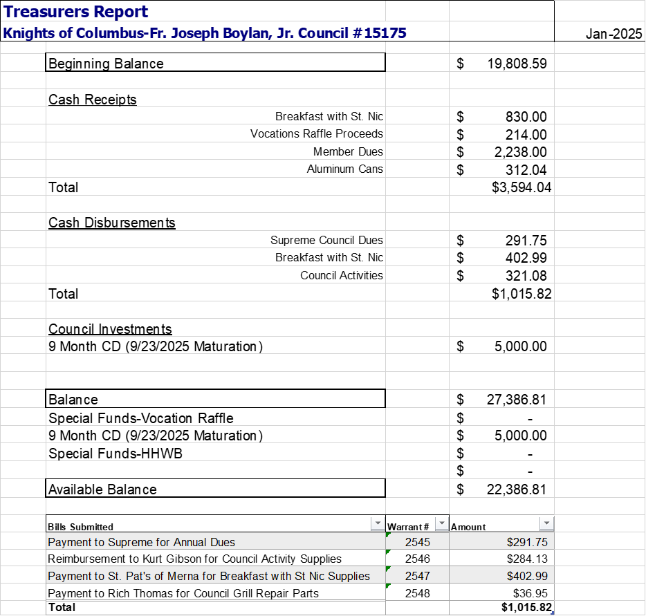

1st Joe Klingler

2nd Jeff Lopez

Motion Passed.

**Financial Secretary Report:** February 4, 2025

Worthy Financial Secretary Dave Blaser reported:

* February Member Report
  + 124 Members (77 Associate / 41 Insurance / 6 Inactive)
    - Plus FIVE from January reflecting the following transfers in:
    - Joseph Arnold
    - Daniel Brady
    - Jeff Day
    - Gregory Meyer
    - Ismael (Tito) Torres
  + Two member withdrawals have been requested; but not yet processed by Supreme. Once processed, the active member count will decrease by two:
    - Chad Baldwin
    - Kevin Kuebler
  + Membership breakdown:
    - Active Membership (118):
      * 76 active members with 3rd degree
      * 23 active members with 4th degree
      * 19 active members without 2nd, 3rd, or 4th degree
    - Within Active Membership:
      * 5 Honorary members
      * 11 Honorary Life members
      * 1 Exempt member

2025 Dues

* 1st notices were mailed Dec. 4, 2024
* 2nd notices were mailed Jan. 11, 2025
* Five members owe a total of $200. All other members are current.
* Knight Alert notices will be sent by 2/15 to members with balances.

February Birthdays:

|  |  |
| --- | --- |
| Derek Price | 2/3 |
| Jerry Schrad | 2/3 |
| Greg Meyer | 2/6 |
| Michael Smeltzer | 2/7 |
| Clint Stroh | 2/15 |
| Mike Vogel | 2/15 |
| Bryan Gomolchak | 2/20 |
| Dan Muller | 2/21 |
| John Pieper | 2/25 |
| Tito Torres | 2/25 |

**The Trustees Report:**

Brother Tony McCauley reported the following concerning the 6-month audit conducted on February 3, 2025:

* Cash on hand in July was $28,877.30
* Current cash on hand is $19,808.59
* The council has invested in a $5,000 CD, which is scheduled to mature in September of 2025.
* There has been a net decrease of $4,069 in council funds.
* In the course of the audit, a $418.13 discrepancy was discovered. It is believed that the discrepancy occurred during the July 2023-January 2024 6-month period.
* The trustees do not believe any additional bonding is needed by the council at this time.

**Chancellor’s Report:**

* No report

**Program Committee Report:**

* Worthy Deputy Grand Knight Phil Olinger reported on the following up-coming events:
  + February 8: 8 for 8 Rosary
  + February 8: TAPS at St. Pats (7-9 pm)
  + February 18: Social Meeting with Downs council at Shamrock Shed (6:30 pm)
  + March 4: March business meeting (7 pm)
  + March 5: Ash Wednesday
  + March 7: Corpus Christi Fish Fry
  + March 18: council meeting to clean closet and loft (meal to be provided; 6:00 pm)

**Field Agent Report:**

No Report.

**District Deputy Report:**

* Worthy District Deputy Mike Tomlianovich reported the following:
  + A 4th Degree exemplification was held in Dwight last month. Seven members from our district attended and received their 4th degree.
  + Some councils are foregoing dues for its members. Those councils are having to consider other fundraising means to replace the funds. More information could be forthcoming from the state on this topic in the coming months.
  + In what can be perceived as an answer to prayers, four Planned Parenthood facilities have closed or are closing in Illinois in recent months, including the facility in Bloomington.
  + The District Deputy’s council conducted a citizenship essay contest with Central Catholic Students. Two CCHS students were recognized as first place winners in their respective grades. In 9th grade, Beatrice Pawley won the contest, while 12th grader Oliver Rohrig was named winner. Oliver is a member of St. Patrick Church of Merna, making the win even more special.

**Old Business:**

* The following topics were discussed/acted on as part of old business:
  + The council voted on a tabled recommendation from January to donate $700 to Angel Garcia, a seminarian in Winona, MN, whose home parish is St. Mary’s in Bloomington. Angel and his family lost their home in a fire this past fall. $583 of the $700 came from vocations raffle earnings, $100 from reimbursement from Supreme Council, and $13 from council funds.
    - 1st Tim Abel
    - 2nd Derek Price
      * Motion Passed
  + Brother Tony McCauley updated the council on TAPS at St. Pats. Brothers were reminded that there is a Sign-Up Genius on the council website for any brother able to assist with the event. 11 brewers are expected to participate in this year’s event. Due to a change in Diocesan policy, additional insurance was needed this year. Proceeds from the event are ear marked for the CCHS Music Parents Booster Club/Group.
  + After much discussion, it was determined to not hold a meal event during Lent. Shamrock Hall was not available on any favorable dates to hold an event this year, and the council agreed it would be wise to establish a date for such an event in 2026 and get it on the church calendar to ensure the necessary space is available.
  + The council also spent considerable time discussing the fundraising idea brought forth by Brother Rich Staley last month. Rich reported that the Downs council was interested in participating in the event, and ultimately the council decided a committee should be formed (including members from the Downs council) to discuss details and logistics for the program. The council expressed general support for the idea being presented, but expressed a desire to hear how the program would fully function before voting to formally move forward with the event. Rich Staley and Grand Knight Kurt Gibson will form the committee, and it is expected the committee will report back to the council with updates over the next few months.
  + The council agreed to tithe $18.03 back to the church from the Steak Dinner held this past fall. In closing out the event, the council had overlooked tithing.

**New Business:**

* Grand Knight Kurt Gibson reminded the council of the February 18th meeting with the Downs council. The event, which will primarily be a social event to allow members of both councils to become more familiar with one another, will be held at Shamrock Shed and begin at 6:30 pm.

**Good of the Order:**

* Worthy District Deputy Mike Tomlianovich reported he has an upcoming hip replacement.

**Prayer Requests:**

* Brother Tony McCauley asked for continued prayers for his brother Joe, who was recently diagnosed with cancer.
* Brother Joe Klingler asked for prayers for the success of the upcoming TEC. Specifically, prayers for the TEC team and attendees.
* Worthy Treasurer Bryan Gomolchak asked for prayers for his father-in-law Michael Door, whose health is declining.
* Deacon Mike Pool asked for prayers for parishioner Genevieve Christie, who will turn 100 on February 26th.
* Additional prayers were offered for the souls of the following individuals who have passed away:
  + Father Michael Gould
  + Parishioner Karen Udell
  + Parishioner Jenny Kamp

**Motion to Adjourn:**

* 1st Rich Staley
* 2nd Craig Queen

Motion Passed

Closing Prayer including the intentions mentioned above under ‘prayer requests’.

Meeting adjourned at 8:31 pm.