March 4, 2025

The Council meeting was called to order at 6:59 pm.

The roll of officers was called and noted as follows (P – Present; A – Absent):

|  |  |  |  |  |  |
| --- | --- | --- | --- | --- | --- |
| Chaplain (Father Schultz) | A | Financial Secretary (Dave Blaser) | A | Inside Guard (Derek Price) | A |
| Grand Knight (Kurt Gibson) | P | Treasurer (Bryan Gomolchak) | A | Outside Guard (Darren Carr) | A |
| Deputy Grand Knight (Phil Olinger) | P | Lecturer | - | Trustee (Guy DiCiaula) | P |
| Chancellor (Shawn Long) | A | Advocate (Rich Staley) | P | Trustee (John Fruin) | P |
| Recorder (Brock Selkow) | P | Warden (Jake Newman) | P | Trustee (Tony McCauley) | P |

The Opening Prayer was “Our Father.”

The Pledge of Allegiance was recited by all members present.

The minutes of the preceding meeting were sent via email and approved.

1st Rich Staley

2nd Mike Long

Motion Carries

**Chaplain Report:**

Jeff Lopez reported:

* We are a long week into our new parish organization.
* Please be patient with the church as we are all getting used to the change.
  + Things like the Rooted prayer are being looked at.
  + A new ID number for a new bank account is being created.
    - This will affect charitable giving, but not online giving.
* Tomorrow is Ash Wednesday, the first day of the Lenten season.

**Grand Knight Report:**

Kurt Gibson reported:

* The council received a Thank You note from Angel Garcia, Seminarian from St. Mary’s Parish in Bloomington, to whom the council made a donation last month.
* Thank you to Tony McCauley for his incredible hard work putting the Taps event together and to those who assisted with or supported the event.
* Joe Klinger will be conducting the first Golf Committee meeting right after this meeting.

**Treasurer Report**

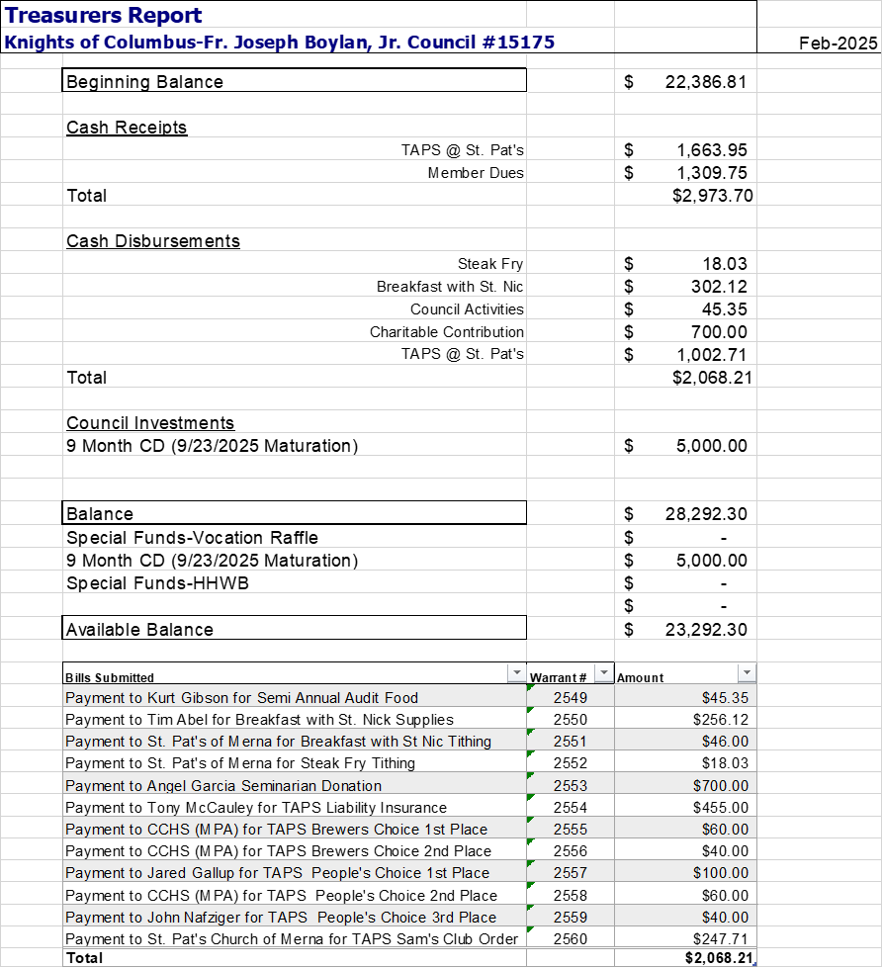

1st John Fruin

2nd Joe Klinger

Motion Carries

**Financial Secretary Report:**

Financial Secretary Report: March 4, 2025

* March Member Report – Not available
* 2025 Dues
  + 1st notices were mailed Dec. 4, 2024
  + 2nd notices were mailed Jan. 11, 2025
  + Knight Alert notices were mailed Feb. 24, 2025
  + Five members owe a total of $200 and are now in “Knight Alert” status. Follow-ups by email and by US mail have been sent. All other members are current.
* The Form 990-N “e-postcard” tax form for 2024 was filed and accepted by the IRS on 2/23. The deadline is May 15.
* March Birthdays:

|  |  |
| --- | --- |
| Alan McDowell | 3/5 |
| Jeff Day | 3/7 |
| Michael Fowler | 3/10 |
| Jeff Furler | 3/11 |
| Steve Giusti | 3/13 |
| Jeff Lopez | 3/14 |
| Tom Knoblauch | 3/19 |
| Thomas Ajster | 3/23 |
| Christopher Olsen | 3/24 |
| John Lueschen | 3/29 |
| Christopher Matthew | 3/30 |

**The Trustees Report:**

* No Report

**The Chancellors Report:**

* No Report

**Deputy Grand Knight Report**

* March Events
  + Friday March 7 - Fish Fry @ Corpus Christi
  + Saturday March 8th - 6am to 2pm Rosary
* April Events
  + Tuesday April 1st - KofC meeting at 7pm
  + Tuesday April 8th - 6am to 2pm Rosary
  + Sunday April 20th - Easter Sunday
  + Church Clean up - Either April 5th or 12th - Checking in with Rodney (Grounds Maintenance). More to come.
  + Tuesday April 22nd - Roadside Clean Up at 5pm.
* May Events
  + Wednesday May 14th - MidWest Food Bank at 6pm. Sign up for this event through the MWFB website.

**Unfinished Business:**

Tony McCauley Reported

* Taps Update:
  + Attendance was 74 paid – 58 tasting, 16 – non-tasting; 11 brewers pouring; 8-12 Knights supporting. Total of 95-100 present. Paid attendance was down by 15 from 2023 and 2024.
  + Cost of Dram Shop/Liquor Liability Insurance up 3 times from past events (154 to 455). Due primarily to the discovery that the limit required by the diocese is $2M vs. $1M we’ve purchased in the past.
  + Pulled pork was prepared by me. Part of it was donated (leftovers from Charla’s wedding). Comments I heard is it was well received.
  + Gross income $1701.
  + Expenses $1118.49
  + Net profit $582.51
  + Tithe $58.25 ($36.90 already donated. Check needed for $21.35)
  + Available for donations $524.26.
    - Tony Motioned to donate $500 to Central Catholic Music Parents Association.
    - Jeff Lopez 2nd
      * Motion Carries

Jeff Lopez Reported

* 5 Volunteers are already signed up to help with the Corpus Christi Fish Fry this Friday.
  + We need a few more.
  + Set up 2:30 - 3pm
  + 4:30 the event needs to be ready to go. Event is from 5-7pm

Rich Staley Reported

* The Raffle Fundraising Committee held its 1st meeting.
* A series of questions are being compiled and a sample ticket was passed for viewing.

**New Business:**

Kurt Gibson Reported

* Tuesday March 18th - KofC Closet Clean Out will be at 6:30pm in the shed.
  + There are several items that need to be looked at and evaluated for their usefulness.
* This past February we had a member of our parish (Oliver Rohrig) win an essay contest hosted by KofC council #574.
  + The question was asked “Should we support him”?
  + The council discussed support and concluded that we will put a message of congratulations in the bulletin.
    - If there are any other instances of congratulations that we need to recognize, please let the council know.

Jeff Lopez Reported

* Parishioners helping Parishioners: We have received word from a parishioner that some light work needs to be done to her basement (Drywall and Painting). The question was proposed “Are we willing to donate our time to help”?
  + The council discussed and agreed that we can and should help. Jeff will be reaching out to the members of the council for a sign up to help.
* Sacred Heart Holy Hour: The Diocese of Peoria has a religious icon that can be displayed in the church along with readings and prayers to be held by our priests. The question was proposed “Do we want to market this event, as well as attend, and do we want to coordinate with Fr. Shultz to have a priest or priests conduct the holy hour”?
  + The council discussed and agreed that the holy hour sounded like a good time and with some marketing to other KofC councils as well as other parishes, could be a well-attended event.
  + Jeff will start the initial inquiries to Fr. Shultz and report back with his findings, hopefully as soon as April.

**Field Agent Report:**

* No Report

**Good of the Order:**

John Fruin Reported

* The 2025 Men’s Lenten Breakfast will take place Wednesday April 2nd from 7-8:30am at the DoubleTree Hotel in Bloomington. This year's speaker is Al Mueller, Founder and CEO of Excellence in Giving. Tickets are $40 per person. The question was proposed “Will the KofC contribute financially to offset some of the cost for our members attending”?
  + The council discussed and requested John reach out to see how many sit at a table.

Jeff Lopez Reported

* The Diocese of Peoria’s 150 anniversary is underway and all Priests as well as Deacons are required to have special vestments for this anniversary. The cost of these vestments is $900 per person. The question was proposed “Do we as a council want to pay for the vestments for our Priests and Deacons”?
  + The council discussed and agreed that we should reach out to our brothers in the Downs council to help financially.
  + More discussion to follow on this topic in April.

**Prayer Requests:**

* Deacon Mike Pool: Roland Grotbo has now been placed in hospice. Please keep him and his family in your prayers.
* Jeff Lopez: Lou Kanovski’s wife has had some health issues. Lou is a Brother Knight from the Spaulding council. Please keep them both in your prayers.
* Jake Newman: Pope Francis is ill. Please keep the Holy Father in your prayers.
* Tim Abel: Cursillo is happening this weekend. Please keep Rich Thomas and Fr. Matt in your prayers as well as all of the attendees.
* Guy DiCiaula: His friend's mother has had some dementia issues. Please keep her in your prayers.

**Motion to Adjourn:**

* 1st Rich Staley
* 2nd Joe Klinger

Closing Prayer including the intentions mentioned above under ‘prayer requests’.

Meeting called to close at 8:10pm