The Council meeting was called to order at 6:58 pm.

The roll of officers was called and noted as follows (P – Present; A – Absent):

|  |  |  |  |  |  |
| --- | --- | --- | --- | --- | --- |
| Chaplain (Father Schultz) | A | Financial Secretary (Dave Blaser) | P | Inside Guard (Derek Price) | A |
| Grand Knight (Kurt Gibson) | P | Treasurer (Bryan Gomolchak) | P | Outside Guard (Darren Carr) | P |
| Deputy Grand Knight (Phil Olinger) | P | Lecturer | - | Trustee (Guy DiCiaula) | P |
| Chancellor (Shawn Long) | A | Advocate (Rich Staley) | A | Trustee (John Fruin) | A |
| Recorder (Brock Selkow) | P | Warden (Jake Newman) | P | Trustee (Tony McCauley) | P |

The Opening Prayer was “Our Father.”

The Pledge of Allegiance was recited by all members present.

The minutes of the preceding meeting were sent via email and approved.

1st Greg Meyer

2nd Tony McCauley

Motion Carries

**Chaplain Report:**

Kurt Gibson Reported:

* Thank you to all Knights who participated in the get together with the Downs council.
* The permit is secured for the new rectory.
* The merger is almost complete with St. Mary’s Church in Downs. The website is almost done. A new staff member has been hired, Joey Ells, He is the new Men’s Evangelization Director. He starts in Mid-June.

**Grand Knight Report:**

Kurt Gibson reported:

* Thank you to all who helped with painting, cleaning the church grounds, and roadside clean up.
* Jess Elliot has requested for council participation in The National Eucharistic Pilgrimage on May 20th.
  + Mass is at 10am St. Patrick Church of Merna Catholic Church, Walk at 11:30am.
  + Starts at Central Catholic HS, then to McGraw Park.
  + Sign up Genius coming soon.
* Keep conclave in your prayers.

**Treasurer Report**

Bryan Gomolchak Reported:

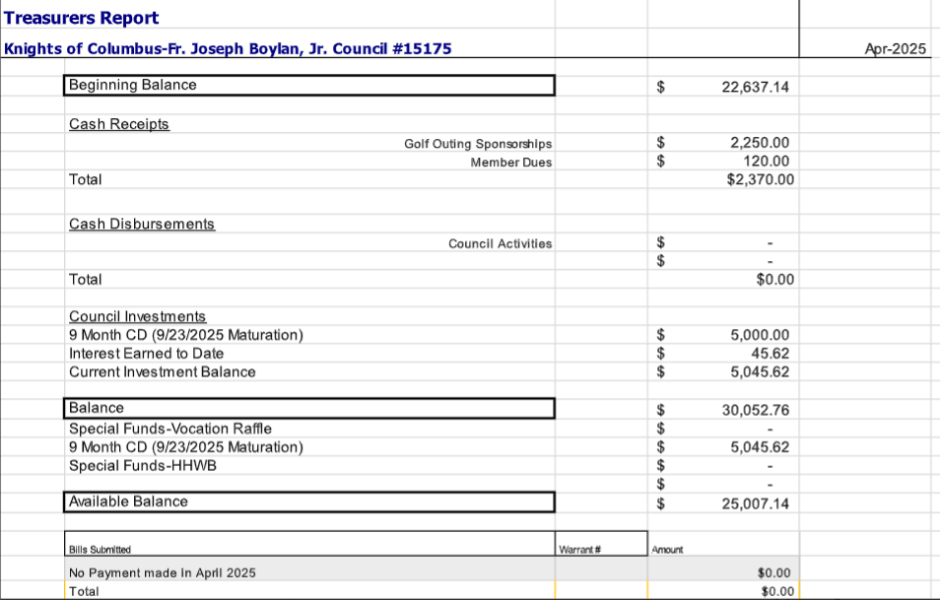

1st Tim Abel

2nd Mike Long

Motion Carries

**Financial Secretary Report:**

Dave Blaser Reported:

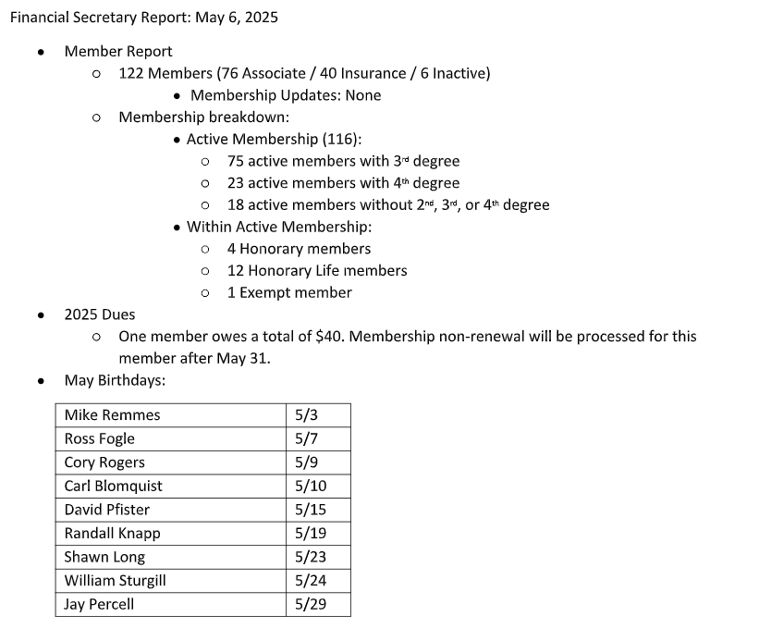

**The Trustees Report:**

Guy DiCiaula reported on the slate of officers for 2025-26 being proposed by the Trustees. These will be voted on at the June meeting. Note there are some openings for interested Brothers.

Chaplain Father Schultz

Grand Knight Kurt Gibson

Deputy Grand Knight Phil Olinger

Chancellor Shawn Long

Recorder Brock Selkow

Financial Secretary Dave Blaser

Treasurer Bryan Gomolchak

Lecturer vacant

Advocate Rich Staley

Warden Jake Newman

Inside Guard Derek Price

Outside Guard Darren Carr

Trustee John Fruin

Trustee Tony McCauley

Trustee Guy DiCiaula

**The Chancellors Report:**

* No Report

**Deputy Grand Knight Report**

* May Events
  + May 14th - MidWest Food Bank 6-8pm
  + May 17th - Hungarian Sausage Meal 12-1pm
  + May 20th - National Eucharistic Pilgrimage 12pm
  + May 20th - 6-month planning meeting (Shed) 6pm
* June Events
  + June 3rd - KofC council meeting
  + June 8th - Rosary
  + June 17th - Roadside Cleanup 5pm
  + June 21st - Pork Chop Dinner (tentative)

**Unfinished Business:**

* Kurt Gibson reported in John Fruin’s absence:
  + Vocations Raffle has been updated for 2025.
    - Books now have 5 tickets for $20 a book ($4 a ticket).
    - Books will be on sale from July 1st - Nov 15th.
    - We have a Council Challenge to sell 100 books this year.
    - We would like to reduce the postage costs this year, so we can distribute books during meetings.
* Kurt Gibson Reported:
  + Most Holy Eucharist Parish Knights of Columbus Raffle Fundraiser
    - Committee meeting for fundraiser May 22nd.
    - We want 2 groups to receive funds from this fundraiser, Parishioners helping Parishioners & St. Vincent DePaul.
    - $25 per ticket/ 250 Tickets to be sold total. $50 payout for drawings, except for the last drawing of each month, which will result in a $100 payout.
    - Expenses should be $325/ $4,600 should be raised.
    - Rich Staley is the point person for sales. He will be tracking who bought them.
    - We will start selling tickets in August. We will stop around Thanksgiving.
      * You can return the sold tickets to the welcome center or office.
  + Winners will be posted on the KofC website.
  + No electronic payments will be accepted this year.
* Joe Klingler Reported:
  + Golf Meeting May 13th 5:30pm
  + $125 per person. Outing Thursday August 21st at Ironwood Golf Course.

**New Business:**

* Tim Abel Reported:
  + KofC food events calendar is being developed.
  + We are looking to provide quality and consistency. We are also trying to tie each food event to a religious event.
  + Information available on the KofC website.
* Tim Abel Reported:
  + Habitat for Humanity Wall Build. This year there is not a need for a wall build. We will be holding the budget line for next year.
  + Communication will be going out to the parish that we will not be having a wall build this year.
* Tony McCauley Reported:
  + Keg Grove will be sponsoring a hole for the golf outing in August.
  + Western Avenue Community Center needs support for their golf outing July 11th.
    - Tony McCauley motioned to provide $200.
    - 2nd Joe Klingler
    - Motion passes
* Kurt Gibson Reported:
  + $600 to provide new vestments to the parish clergy.
  + Motion carried from April Meeting.
  + Motion passed.

**Field Agent Report:**

* No Report

**Good of the Order:**

* No Report

**Prayer Requests:**

* Pope Francis
* The Conclave
* Carl Blomquist.

**Motion to Adjourn:**

* 1st Tim Abel
* 2nd Mike Long

Closing Prayer including the intentions mentioned above under ‘prayer requests’.

Meeting called to close at 8:10pm