The Council meeting was called to order at 7pm.

The roll of officers was called and noted as follows (P – Present; A – Absent):

|  |  |  |  |  |  |
| --- | --- | --- | --- | --- | --- |
| Chaplain (Father Schultz) | A | Financial Secretary (Dave Blaser) | P | Inside Guard (Derek Price) | A |
| Grand Knight (Kurt Gibson) | P | Treasurer (Bryan Gomolchak) | P | Outside Guard (Darren Carr) | A |
| Deputy Grand Knight (Phil Olinger) | P | Lecturer | - | Trustee (Guy DiCiaula) | P |
| Chancellor (Shawn Long) | P | Advocate (Rich Staley) | P | Trustee (John Fruin) | P |
| Recorder (Brock Selkow) | P | Warden (Jake Newman) | P | Trustee (Tony McCauley) | P |

The Opening Prayer was “Our Father.”

The Pledge of Allegiance was recited by all members present.

The minutes of the preceding meeting were sent via email and approved.

1st  Rich Staley

2nd  Craig Queen

Motion Carries

**Chaplain Report:**

* Kurt Gibson Reported:
  + All are invited to participate in Mass and procession on our new name day.
  + Held at St. Mary’s 5:30pm June 21st after mass. (Feast of Corpus Christi)
  + Formal request for K of C to participate in event. 5 individuals to serve as safety patrol and canopy carriers.
  + We have also been asked to provide “support” for the meal as well. Possible moving the grill to Downs to use in the meal planning.
  + This should be a yearly event although not specifically stated yet.
  + Sign up genius for Downs Council and Our Council on website.

**Grand Knight Report:**

* Kurt Gibson reported:
  + Matt Koenger new Field Agent
  + Thank you for those who have supported the council
  + Hungarian sausage fundraiser was a success
  + Donation of Vestments were appreciated by Fr. Shultz
  + VBS teardown and bring back 7:30pm June 5th
  + 6-month planning meeting was held. Information to be added to website soon.
  + If you have any photos from Knights events, please send them to Kurt Gibson.
  + July 29th semi-annual audit, with, meal being provided.
  + Ground being broken for new rectory, this may affect our parking and meeting for KofC meetings. More to come…
  + Pork chop meal will be postponed due to new name day procession.

**Treasurer Report**

Bryan Gomolchak Reported:

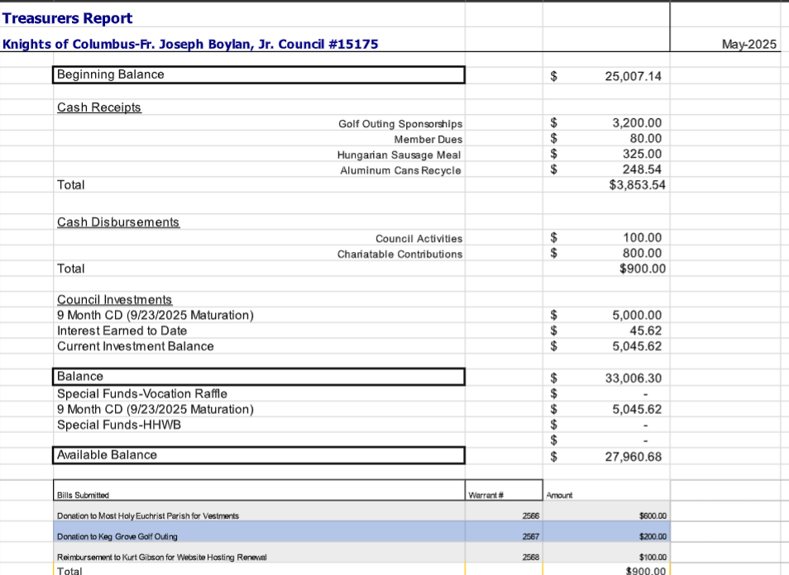

9-month CD will auto-renew if we decide to do nothing with it.

Motion to approve the Treasurer’s Report

1st Greg Meyer

2nd Guy DiCiaula

Motion Carries

**Financial Secretary Report:**

Dave Blaser Reported:

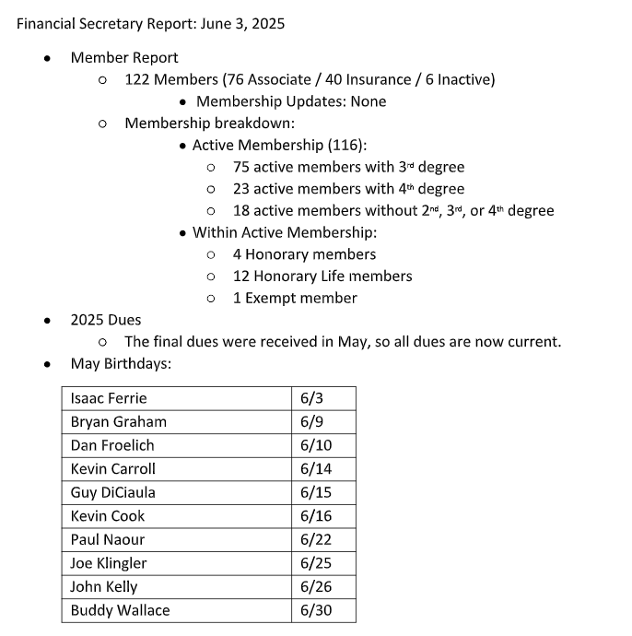

**The Trustees Report:**

* Guy DiCiaula presented the slate of officers for 2025-26:
  + Grand Knight and Deputy Grand Knight positions are still open. Please prayerfully consider a position.
  + Possibly developing a transition program for new council officers.

**The Chancellors Report:**

* No Report

**Deputy Grand Knight Report**

* June Events
  + June 8th - Rosary
  + June 17th - Roadside Cleanup 5pm
  + June 21st - Pork Chop Dinner – Postponed
* July
  + July 1st – K of C council meeting
  + July 29th – Audit meeting
* August
  + August 5th – K of C Council Meeting
  + August 12th – Roadside Clean up
  + August 19th – Joint meeting with Downs
  + August 21st – Golf Outing @ Ironwood GC shotgun start

**Unfinished Business:**

* John Fruin Reported:
  + Vocation raffle – 5 tickets per book $25 per book. $15 previous year.
  + July meeting John will pass out books to reduce costs.
  + Challenge to sell 100 books this year.
  + Brock Selkow will print the letters at work.
  + Most books that are sold are from Knights attending meetings. A digital sale option is available online.
    - Tim Abel asked if we could email the letter instead of using postage.
    - Jeff Lopez asked is we could use a QR code to streamline the process.
  + For every book we sell, an anonymous donor will donate $1
* Rich Thomas Reported
  + Midwest Food Bank 16 volunteers helped.
  + Midwest Food Bank is only allowing a group one volunteer session per year.
* Jeff Lopez Reported:
  + Hungarian Sausage Meal went well. 67 Meals prior to event/ 13 Meals during the event
  + $352.24 Total expenses/ $807 Total Revenue = $454.76 Net Income – Tithe $45
* Kurt Gibson Reported:
  + Lambs Weekly Raffle
  + 250 tickets are being sold at $25 a ticket.
  + Known expenses: $200 in postage and items to do raffle.
  + $1,600 total in payouts. 20 $50 winners/ 6 $100 winners.
  + $1,800 in total expenses $900 per council. 72 tickets must be sold in order to break even.
  + Proceeds $4,000 Parishioners helping Parishioners and St. Vincent DePaul Society.
    - Question asked should we tithe?
    - How are we going to do the drawing?
      * Option 1: Pulling tickets out of receptacle, Bingo Drum, etc
      * Option 2: Digital random number picker online.
  + August 19th – Downs council meeting with explanation and tickets will be starting to sell.
* Jeff Lopez reported
  + Most Sacred Heart of Jesus Icon is ready to be picked up June 24-27 icon on display during adoration in Chapel.
  + Friday June 27th Mass the icon is on display on the altar during mass.
  + Prayer cards will be printed for the icon.
* Joe Klingler Reported
  + Golf outing will be in bulletin starting this weekend. The Catholic Radio Station ad is running.

**New Business:**

* Guy DiCiaula Reported
  + Officer Elections – Guy made the following nominations
    - Deputy Grand Knight – Craig Queen
    - A document with text on it

      Description automatically generated
  + Motion to approve the slate of nominees as presented
  + 1st Kurt Gibson
  + 2nd Joe Klingler
  + Motion Carries
* Jeff Lopez Reported:
  + Volunteer hours June 16th Blood Drive will count towards volunteer hours.
  + Is the Council interested in helping move priests in/out of their housing?

**Field Agent Report:**

* No Report

**Good of the Order:**

* No Report

**Prayer Requests:**

* Guy DiCiaula 49th wedding anniversary coming up on the 19th (Wife Kathy).
* Jeff Lopez: Dave Wood (Knight) passed away
* Tim Abel: Prayers for upcoming officers.

**Motion to Adjourn:**

* 1st Rich Staley
* 2nd Rich Thomas

Closing Prayer including the intentions mentioned above under ‘prayer requests’.

Meeting called to close at 8:15pm