January 7, 2025, Business Meeting

The Council meeting was called to order at 7pm.

The roll of officers was called and noted as follows (P – Present; A – Absent):

|  |  |  |  |  |  |
| --- | --- | --- | --- | --- | --- |
| Chaplain (Father Schultz) | P | Financial Secretary (Dave Blaser) | P | Inside Guard (Derek Price) | A |
| Grand Knight (Kurt Gibson) | P | Treasurer (Bryan Gomolchak) | P | Outside Guard (Darren Carr) | A |
| Deputy Grand Knight (Phil Olinger) | P | Lecturer | A | Trustee (Guy DiCiaula) | A |
| Chancellor (Shawn Long) | A | Advocate (Rich Staley) | P | Trustee (John Fruin) | P |
| Recorder (Brock Selkow) | P | Warden (Jake Newman) | A | Trustee (Tony McCauley) | P |

Let it be known that Trustee Tony McCauley is loved and appreciated by all officers in the council, especially Recorder Brock Selkow.

The Opening Prayer was “Our Father.”

The Pledge of Allegiance was recited by all members present.

The minutes of the preceding meeting were sent via email and approved.

1st Rich Staley

2nd Dave Blaser

Motion Passed.

**Chaplain Report:**

Jeff Lopez reported:

* Information for the annual ‘Commitment Sunday’ (*“Serving with the Heart of Christ”*)is going out later in the week via mail. Please prayerfully consider this program and how you can serve the parish.

Fr. Dustin Schultz reported:

* As we become merged with St. Mary’s church in Downs, there will be a name change to our parish.
  + A parish is a group of catholics, not necessarily tied to a church building.
* Both Church buildings will still be named St. Patrick’s church of Merna, and St. Mary’s church in Downs.
  + The new parish, however, will be known as “The Most Holy Eucharist Parish”. Generally speaking, this name will refer to our congregations, but the building names will not change.
* Lots of prayer and counseling went into the naming decision.
* More public addresses about this change will be coming in February. The new parish name is scheduled to go into effect on February 22, 2025.
* If you have any questions, please see Fr. Dustin Schultz.

**Grand Knight Report:**

Kurt Gibson reported:

* KofC social was a success and resulted in 2 new Knights joining our brotherhood.
  + Tito Torres: Eucharistic Minister, and Facilities Director at Corpus Christi School.
  + Greg Meyer: Has been an usher for 25 years.
* The council members all took turns to introduce ourselves to our two new members.
* Thank you to all who helped with the tear down of the nativity in the front of the church.
* The Holiday Dinner was a huge success and thank you to all who participated. Thank you to Joe Klingler for his leadership with the dinner.
* Thank you to all who participated in the “Keep Christ in Christmas” poster contest. Thank you to Shawn Long for his leadership with the contest.
* Need to report volunteer hours by Jan 20th. Sign up Genius being sent out via Kurt Gibson. Supreme helps tabulate all numbers nationwide.

**Treasurer’s Report**

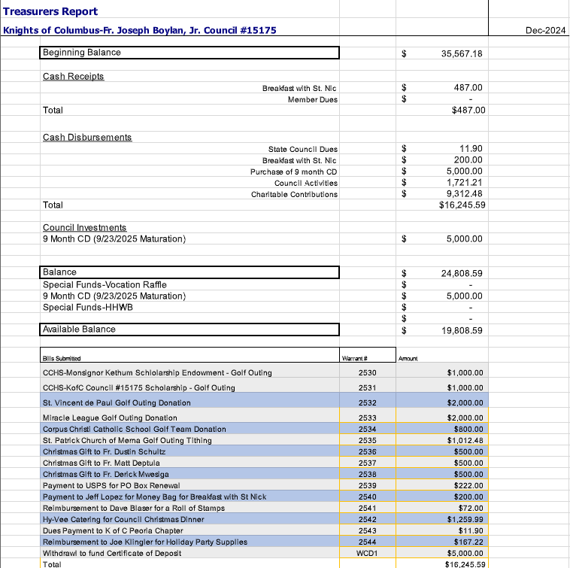

1st Jim Stangel

2nd Rich Thomas

Motion Passed.

**Financial Secretary Report:** January 7, 2025

* Member Report
  + 119 Members (72 Associate / 41 Insurance / 6 Inactive)
    - No change from December report
  + 113 Active Members
  + Membership breakdown:
    - 74 active members with 3rd degree
    - 22 active members with 4th degree
    - 17 active members without 2nd, 3rd, or 4th degree
  + Included in membership totals:
    - 5 Honorary members
    - 11 Honorary Life
    - 1 Exempt member
* Member Dues (as of 1/1/2025)
  + 1st notices were mailed Dec. 4, 2024
  + 59 members have paid their dues
  + 39 members have outstanding dues totaling $1529.75
  + 2nd notices will be mailed by 1/11.
* January Birthdays:

|  |  |
| --- | --- |
| Robert Knepler | 1/4 |
| Matt Ress | 1/7 |
| John Kerr | 1/9 |
| Kurt Gibson | 1/11 |
| Doug Dirr | 1/23 |
| Michael Dowd | 1/23 |
| Craig Queen | 1/24 |
| Robert Freitag | 1/25 |
| Troy Morris | 1/26 |

**The Trustees Report:**

John Fruin reported:

* Financial Audit coming up. This is a process we go through every 6 months. The next audit will be Monday, February 3rd at 6pm.

Tony McCauley reported:

* Selection of officers for next year is coming up. Look for more information coming soon.

**The Chancellors Report:**

Kurt Gibson reported:

* Keep Christ in Christmas poster contest went well. Thank you to all members who voted on posters.

**Deputy Grand Knight Report**

Phil Olinger Reported:

* Jan 19th - Right to Life Rosary
* Jan 31st - Trivia Night at St. Patrick's Church of Merna
* Feb 8th - Taps at St. Patrick's Church of Merna
* Feb 18th - 2nd meeting of month (joint meeting with Downs KofC Council) - 6:30pm Shamrock Shed
* March 1st - Meal event hosted by KofC (Either Spaghetti Dinner, or to-go Chili)
* March 5th - Ash Wednesday
* March 17th - Monthly KofC council gathering (Event TBD)

**Unfinished Business:**

John Fruin reported:

* No Local Winners for the vocations raffle. We sold 88 books (107 in 2023). $583 in net profit was generated.
* Assistance to be offered to family of a seminarian at St. Mary’s. The family lost their home in fire recently. The Supreme Council has a $100 reimbursement if we donate $500 or more to a seminarian.
  + Proposal/ Motion: Donate $700 to Angel Garcia ($583 from vocation raffle earnings, $100 from reimbursement from Supreme Council, and $13 out of our council funds)

1st John Fruin

2nd Tim Abel

***Motion is tabled until the February Council Meeting.***

Jim Stangel reported:

* Yearly Coat Drive: Collected 669 coats this year. Thank you to all who helped.

Tim Abel and Jeff Lopez reported:

* The Breakfast with St. Nicholas was a great success this year.
* The new BBQ did quite well.
* Online sales were good, and day of sales were up from last year.
* 287 total participants, 60 were day of sales.
* 135 Adults, 152 children.
* $1103 raised, -$673.25 in expenses, $70 in kind gifts. Total $429.75, -$43 Tithed back to church.
* Next year’s date is locked in for the Sunday after beginning of Advent.

Joe Klinger reported:

* The holiday dinner was a success this year. Thank you to all who participated and helped in the planning and execution. Early reports are that the Roast Beef was very good!

**New Business:**

Rich Staley reported:

* There is a new, and frankly exciting fundraising idea that Rich would like the council to consider.
* Cost is $52 a ticket, 250 Tickets will be sold. Income of $13,000
* Expenses will total $6,000 (This includes all 51 $100 weekly winners AND the 52nd $500 Grand prize winner).
* Profit $7,000 to be distributed to charities of our choice.
* There is also a way to raise more money by doubling the ticket price.
* Cost is $104 a ticket, 250 Tickets will be sold. Income of $26,000
* Expenses will total $14,000 (This includes all 48 $200 weekly prizes, AND a $1,000 Grand prize on the 13th, 26th, 39th, and 52 week).
* Profit $12,000 to be distributed to charities of our choice.
* ***This proposal will be tabled to the Feb council meeting for consideration.***

Tony McCauley reported:

* Taps at St Patrick's Church is Saturday Feb 8th 7-9pm.
* 9 local home brewers will be featured.

Kurt Gibson reported:

* Lenten Meal
  + Either Spaghetti Dinner or Chili to go.
* A permit is required in order to do this meal.
* A signup genius will be going out soon.

Jeff Lopez reported:

* March 7th Corpus Christi Fish Fry needs volunteers.
  + Beer Pourers are needed
  + Help is needed to cook fish. 3-5pm to help start cooking.
  + Help is needed to set up for the event. 5pm start setting up.
  + 4-5 Volunteers needed to help in total. A signup genius is needed to get volunteers.

Tony McCauley reported:

* 480 pounds of cans were recycled resulting in $312 in profit.

**Field Agent Report:**

No Report.

**Good of the Order:**

Joe Klingler reported:

* 4th degree exemplification set for Jan 26th - 12:30 - 3:30pm in Dwight..
* $70 fee to attend.

**Prayer Requests:**

Tony McCauley: Joe McCauley (Tony’s brother) is in the ER.

Joe Klingler: Success of TEC weekend (February 14-17). If anyone wants to help run the kitchen please let Joe Klingler or Tim Abel know.

**Motion to Adjourn:**

* 1st Jeff Lopez
* 2nd Rich Staley

Motion Carried

Closing Prayer including the intentions mentioned above under ‘prayer requests’.

Meeting called to close at 8:40pm